1. select * from city

where CountryCode='IDN'

order by Population desc

limit 10;

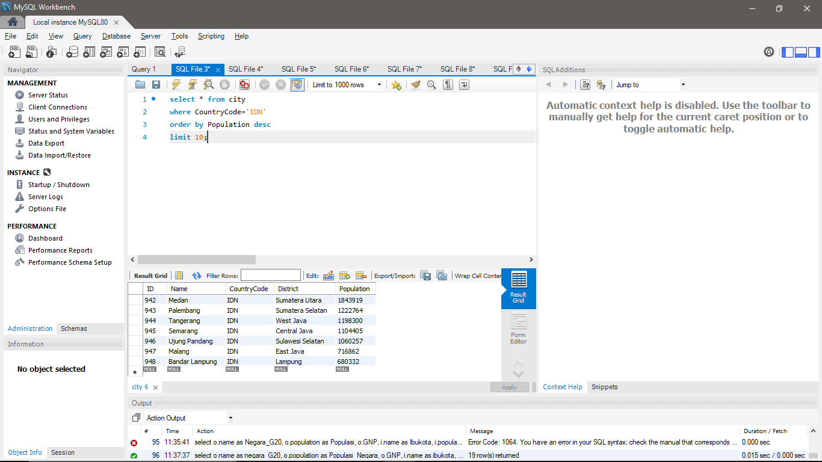

1. select i.id, i.name as nama_kota, i.district, o.Name as negara, i.population

from city i, country o

where i.CountryCode = o.code

order by i.Population desc

limit 10;

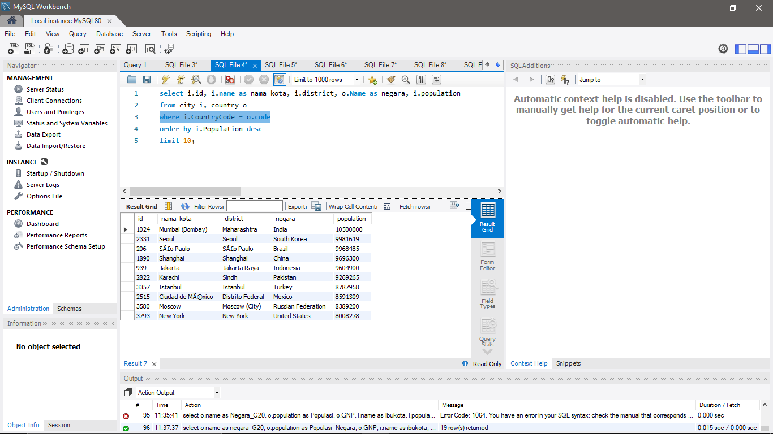

1. select code, name, continent, region, indepyear as tahun_merdeka

from country

where indepyear is not null

order by indepyear

limit 10;

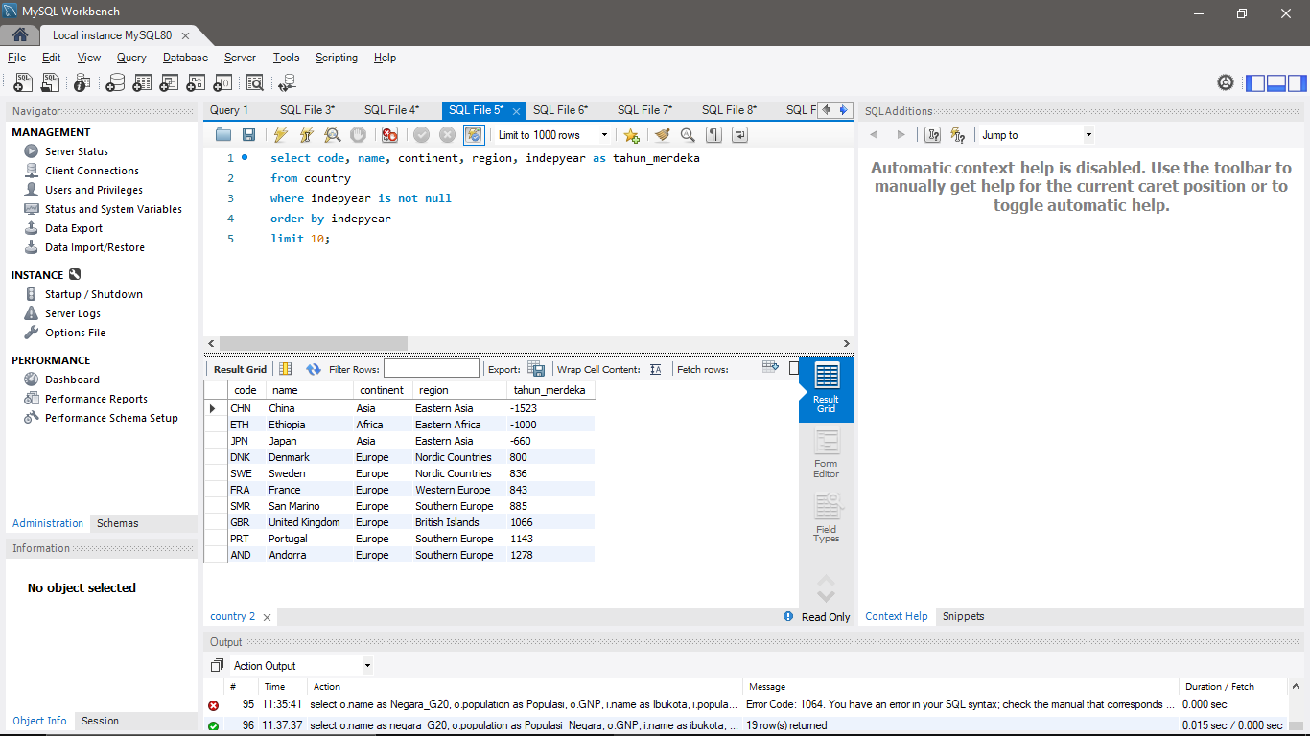

1. select continent, count(name) as jumlah_negara, sum(population) as populasi, avg(lifeexpectancy) as Rata_AngkaHrpnHidup

from country

group by continent

having Rata_AngkaHrpnHidup is not null

order by populasi desc;

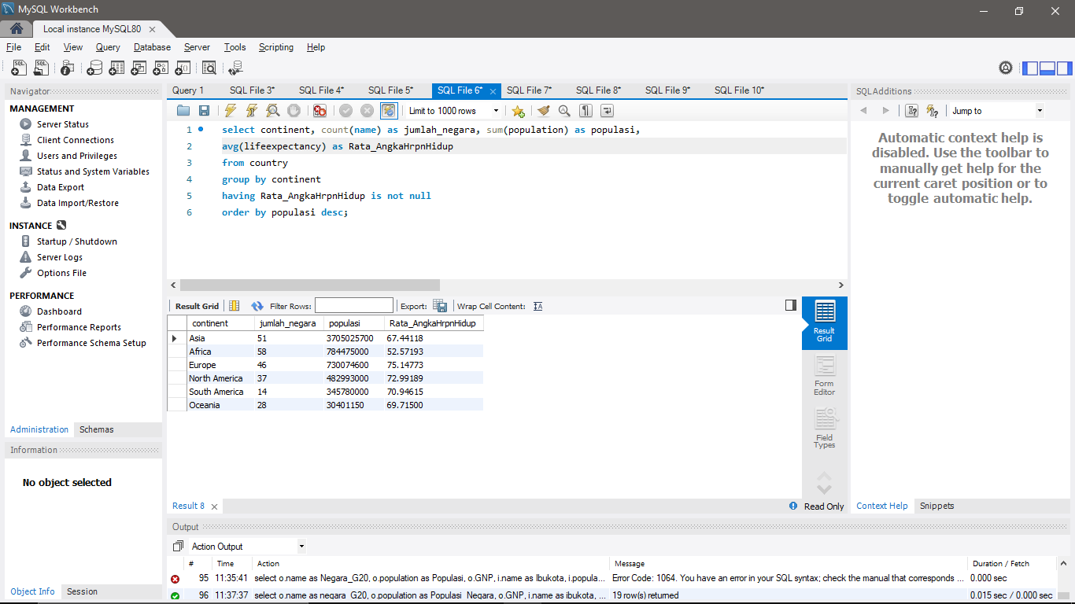

1. select name as Nama, continent as Benua, lifeexpectancy as AngkaHarapanHidup, GNP

from country

where continent='Asia' and

lifeexpectancy > (

select avg(lifeexpectancy)

from country

where continent='Europe'

group by continent)

order by lifeexpectancy desc;

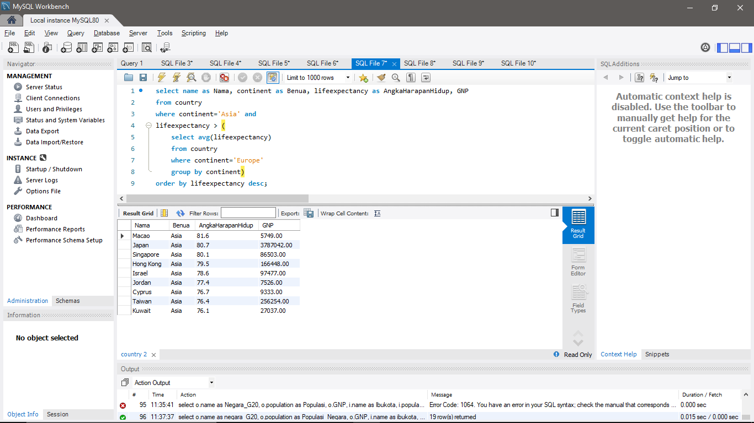

1. select cl.countrycode, c.name, cl.language, cl.isofficial, cl.percentage

from countrylanguage cl, country c

where cl.countrycode = c.code and cl.language='English'

order by cl.percentage desc

limit 10;

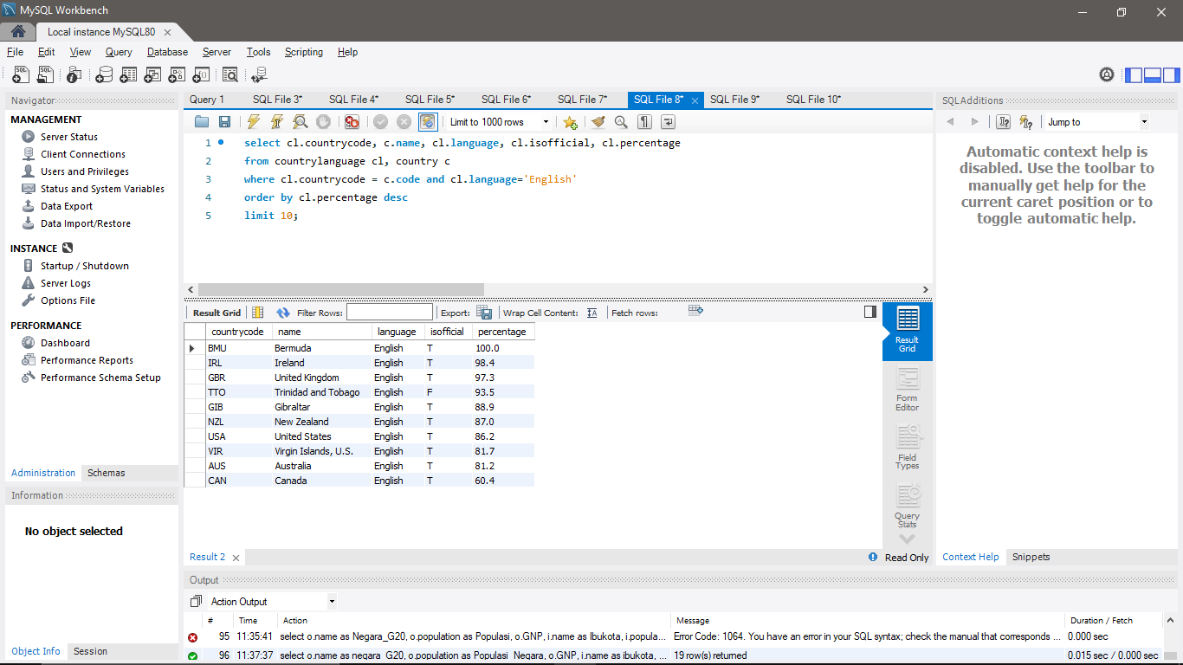

1. select o.name as negara_asean, o.population as Populasi_Negara, o.GNP,

i.name as ibukota, i.population as Populasi_Ibukota

from country o, city i

where i.CountryCode = o.code and o.region='Southeast Asia' and i.name in (

select city.name

from city, country

where city.id = country.capital)

group by o.name

;

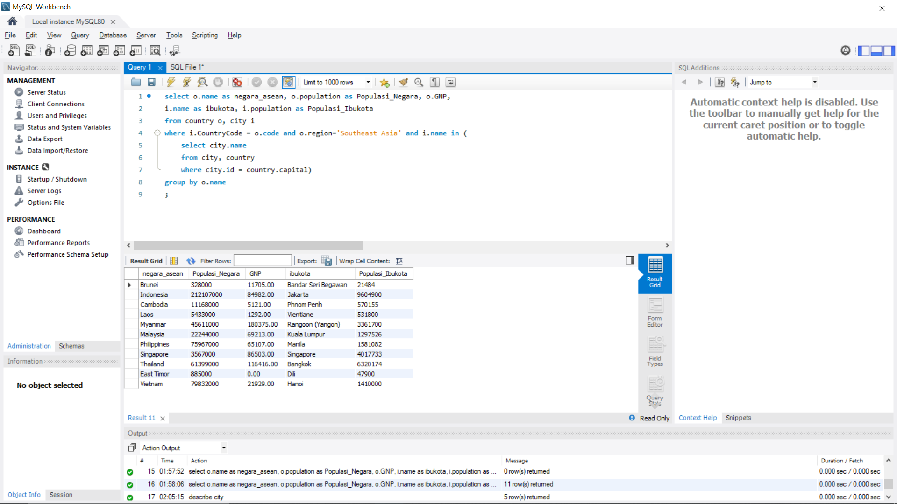

1. select o.name as Negara_G20, o.population as Populasi_Negara, o.GNP,

i.name as ibukota, i.population as Populasi_Ibukota

from country o, city i

where i.CountryCode = o.code

and o.name in (‘Argentina’,’Australia’,’Brazil’,’Canada’,’China’,’France’,’Germany’,’India’,’Indonesia’,’Japan’,’Mexico’,’Russian Federation’,’Saudi Arabia’,’South Africa’,’South Korea’,’Turkey’,’United Kingdom’,’United States’)

and i.name in (

select city.name

from city, country

where city.id = country.capital)

group by o.name

;

